GoldSense AI — XAU/USD Trading Companion

1. Introduction
GoldSense AI is an intelligent, full-stack web application designed as a personal companion for XAU/USD (Gold) traders. It provides a realistic paper-trading simulation environment where traders can practice, refine, and evaluate their strategies without risking real capital.
The platform combines 46+ years of historical gold price data (1979–2026) with real-time live market feeds, pre-computed technical indicators, and an AI-powered trade coaching engine that reviews every closed trade and provides actionable feedback.
Key Objectives
- Strategy Simulation — Allow traders to open and close paper trades with realistic market conditions including bid/ask spreads, stop-loss, and take-profit orders.
- Data-Driven Insights — Replace guesswork with real technical indicators (RSI, MACD, Bollinger Bands, SMA/EMA) computed from actual historical data.
- AI Trade Analytics — After every closed trade, the AI engine scores the trade (0–100), highlights what the trader did well, and suggests specific improvements.
- Live Market Integration — Fetch real-time gold prices from MetalPriceAPI and display live-updating candlestick charts.
- Educational Value — Help traders understand risk management, position sizing, and the importance of stop-losses through hands-on practice.

2. What We Have Done

2.1 Real-Time Trading Dashboard
The centerpiece of the application is a full-screen interactive trading workspace:
- Live Candlestick/Line Chart — Powered by TradingView's Lightweight Charts library, displaying 12,000+ daily bars from 1979 to present day. The chart updates in real-time every 5 seconds with live candle accumulation.
- Toggleable Sidebar — Contains the trading panel, open positions, signals, technical indicators, and price alerts. Can be collapsed to maximize chart space.
- Below-the-Fold Analysis — Scrolling below the chart reveals Market Insights, Performance Summary, Trade Journal, and Equity Curve.

2.2 Paper Trading Engine
A complete order management system built for realistic simulation:
Feature | Description
Market Orders | Instant execution at current bid (sell) or ask (buy) price with simulated spread
Volume Selection | Quick presets (0.1, 0.5, 1, 2, 5 oz) or custom quantity input
Stop-Loss / Take-Profit | Toggle-based SL/TP with distance input ($X away from entry)
Risk: Reward Preview | Shows dollar risk, dollar reward, and R:R ratio before order placement
Order Confirmation | Review dialog showing all order details before execution
Position Management | Close button with Yes/No confirmation, expandable position details
Auto SL/TP Execution | Server-side monitoring triggers SL/TP when price reaches levels (with 30s cooldown)

All trades and positions are persisted in MySQL — they survive page refreshes and server restarts.

2.3 Real Technical Indicators (Dataset-Powered)
Instead of generating random indicator values, the platform loads pre-computed, real technical indicators from a 12,096-row enriched dataset:
- RSI (14-period) — Real Relative Strength Index values
- MACD + Signal Line — Real MACD oscillator with signal crossovers
- Bollinger Bands — Real upper, middle, and lower bands with standard deviation
- SMA (20, 50) — Real Simple Moving Averages
- EMA (20, 50) — Real Exponential Moving Averages
- Volatility (30-day) — Real rolling volatility
- Trend Classification — Pre-labeled trend direction from the dataset
- Next-Day Prediction — target_next_close and target_direction columns for AI signal generation

2.4 AI Market Insights Engine
A natural-language advice system that generates contextual trading commentary:
- Reads real technical indicator values (RSI overbought/oversold, MACD crossovers, Bollinger Band proximity)
- Fetches live financial news via RSS feeds (Investing.com, Yahoo Finance)
- Generates plain-English advice like: "RSI is at 6.5 — extremely oversold. This often precedes a rebound, but falling-knife scenarios are possible. Wait for RSI to cross above 30 before entering."
- News-aware suggestions when geopolitical events or Fed announcements are detected

2.5 AI Trade Analytics Page
A dedicated analytics dashboard accessible via the header button:
- Performance Overview — 4 hero stat cards (Balance, Return %, Win Rate, Profit Factor) + 6 mini stats
- AI Performance Coach — Natural-language summary of overall trading performance
- Trade-by-Trade Review — Each closed trade is expandable with:
  - Score (0–100) displayed as a circular SVG ring
  - Verdict — 🌟 Excellent / ✅ Good / ⚠️ Average / ❌ Needs Improvement
  - What You Did Well — Green-themed highlights (e.g., "Excellent risk management with both SL and TP set")
  - How to Improve — Amber-themed suggestions (e.g., "No Stop-Loss was set. Always protect your capital")
  - Pattern detection: consecutive losses (revenge trading warning), consecutive wins, position sizing analysis
- Filter tabs — View All / Wins only / Losses only

2.6 Price Alerts System
- Users set target price levels with direction (above/below)
- Alerts are persisted in MySQL (survive page refresh)
- Real-time monitoring: alerts trigger with visual pulse animation when price crosses the threshold
- Full CRUD: create, delete, trigger via backend API

2.7 Live Data Pipeline
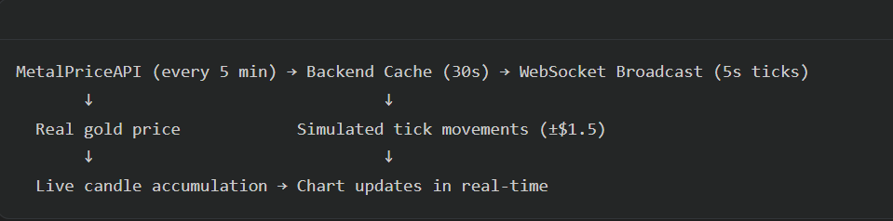
- MetalPriceAPI fetches the real XAU/USD price (API key: configured in .env)
- Between API calls, small tick simulations create realistic price movement
- A live OHLC candle is built from all ticks and appended to the chart
- WebSocket broadcasts live-price and live-candle events every 5 seconds

3. Tech Stack

Frontend
Technology | Version | Purpose
React | 19.x | UI framework — component-based architecture
TypeScript | 5.x | Type safety across the entire frontend
Vite | 6.4 | Build tool and dev server with HMR
Tailwind CSS | 4.x | Utility-first styling with custom design tokens
Zustand | 5.x | Lightweight state management (global store)
Lightweight Charts | 4.x | TradingView's charting library for candlestick/line charts
Socket.IO Client | 4.x | WebSocket connection for real-time data
Lucide React | — | Modern icon library
Inter Font | — | Professional typography via Google Fonts

Backend
Technology | Version | Purpose
Node.js | 22.x | Runtime environment
Express | 4.x | HTTP server and REST API framework
TypeScript | 5.x | Type safety across the entire backend
tsx | — | TypeScript runner (replaced ts-node for ESM support)
Sequelize | 6.x | ORM for MySQL database operations
MySQL | 8.x | Relational database for persistent storage
Socket.IO | 4.x | WebSocket server for real-time broadcasting
dotenv | 17.x | Environment variable management

Data & APIs
Source | Description
xauusd_gold_dataset.csv | 12,096 rows of daily gold data (1979–2026) with 26 columns including pre-computed RSI, MACD, Bollinger Bands, SMA/EMA, trend labels, and ML prediction targets
MetalPriceAPI | Real-time gold price API (metalpriceapi.com)
RSS Feeds | Live financial news from Investing.com and Yahoo Finance for AI insights

Database Schema
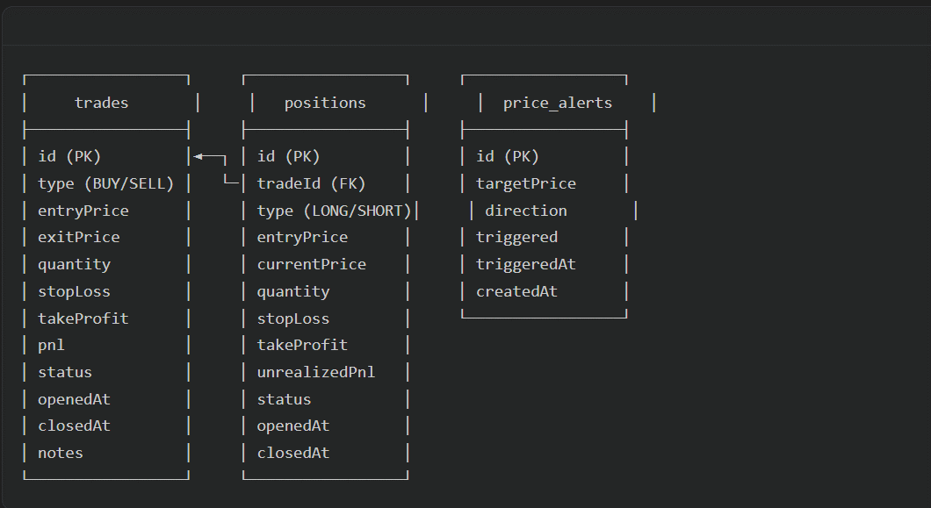

Architecture
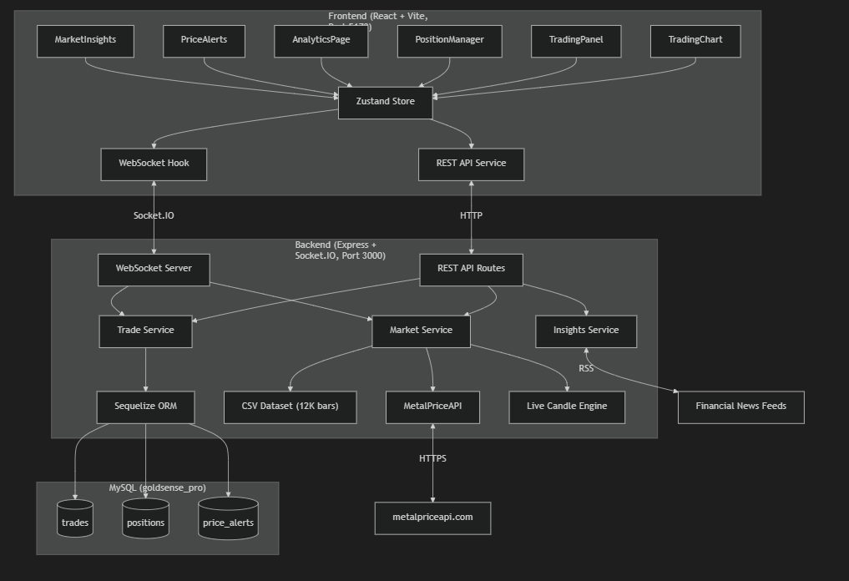

4. Conclusion
GoldSense AI demonstrates the successful integration of real financial data, modern web technologies, and artificial intelligence to create a comprehensive trading simulation platform.
Key Achievements
- Production-Grade Architecture — Clean separation between frontend (React) and backend (Express) with TypeScript throughout, real database persistence, and WebSocket-based real-time communication.
- Data Integrity — Rather than relying on random number generators, the platform uses 46 years of real gold market data with pre-computed technical indicators, providing traders with an authentic simulation experience.
- AI-Powered Feedback Loop — The trade analytics engine doesn't just show numbers — it provides personalized, actionable coaching for every trade, helping users learn from both their successes and mistakes.
- Real-Time Experience — Live price feeds from MetalPriceAPI, WebSocket-driven chart updates, real-time position P&L tracking, and automated SL/TP execution create a near-authentic trading experience.
- Persistence & Reliability — All trading data, positions, and alerts are stored in MySQL. The system handles schema migrations automatically and recovers gracefully from API failures by falling back to simulation mode.

